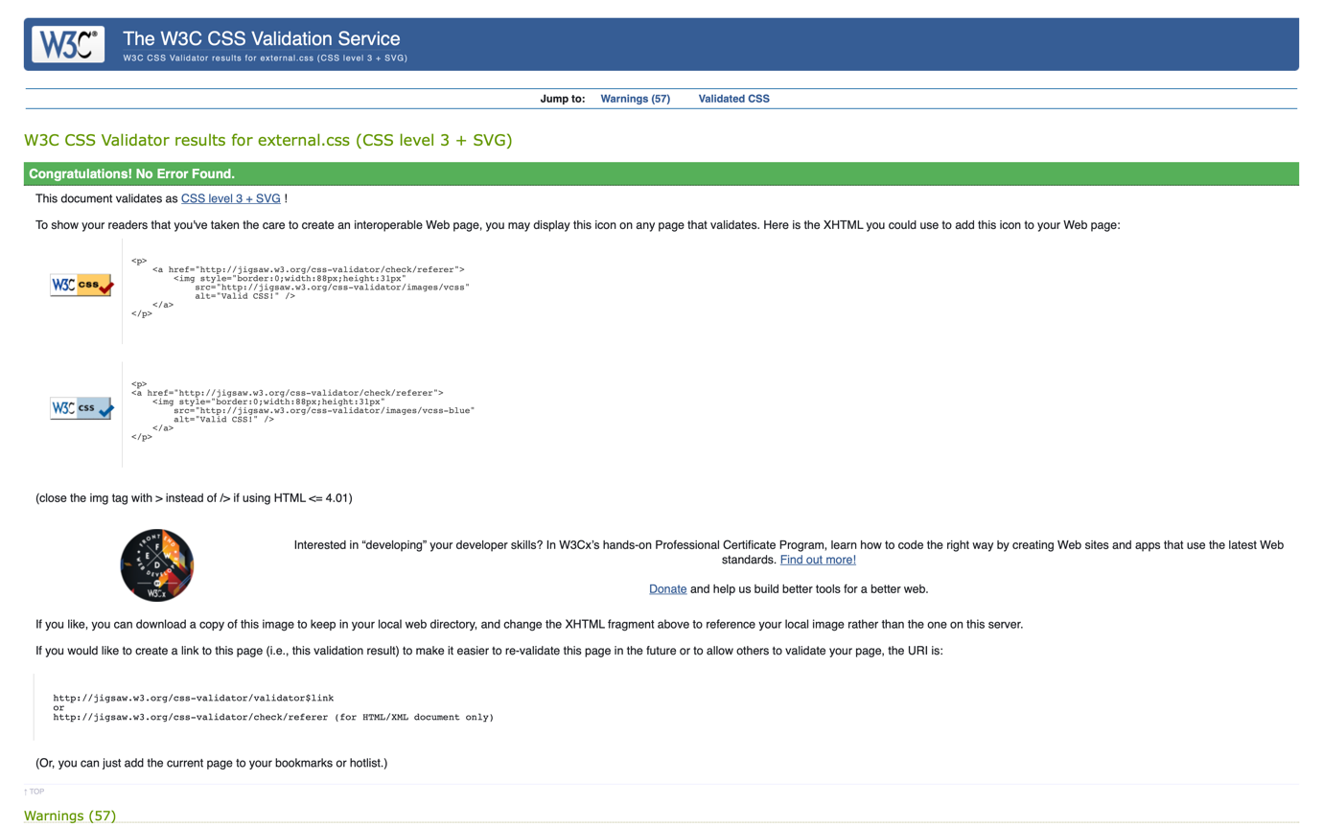

Test CSS general

Test CSS Vinicius page

Performance test

Performance test

Performance test

Performance test

